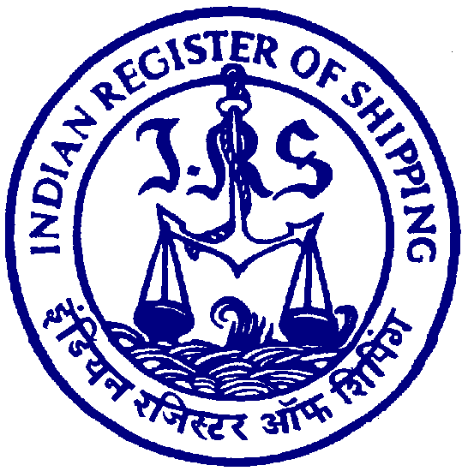
No.: 075/2018 Date: 3rd October 2018

Technical Circular

To whomsoever it may concern

Subject: Exhaust Gas Cleaning Systems with respect to compliance of new Sulphur limit in fuel for Vessels.

- As 1 January 2020 approaches, ship-owners and operators who have chosen to install scrubbers have many questions in their minds. One of them is where can the ship discharge scrubber wash water?

- A list of Regions & Countries which have so far taken a stance and implemented regulation regarding the discharge of wash water effluent from exhaust gas cleaning systems is provided as an annexure to this circular.

- Listed are those, who have additional or different regulations from the IMO MEPC.259(68). The discharge of EGCS effluent will – if not prohibited - only be possible within the limits of the respective regulation.

- Further this is informed that various states, as well as singular ports around the world, that have not currently implemented regulation on the discharge of scrubber wash water, are holding discussions and might also conclude that they will prohibit the discharge of effluent or set their own respective limits before or after 1 January 2020.

- The existing regulations differ in the value limits, the means of measuring and the form of registration ships with operational EGCS’s will have to undertake once in these waters.

- Ship owners/operators and masters are advised to be guided by above.

ANNEXURE

 | Region | Discharge | Comments | Wash water effluent regulation
IMO | Global | Yes | Discharge Possible | IMO EGCS Guidelines (resolution MEPC.259(68))  (See note 1)
EU | EU | Yes | Discharge Possible | Sulphur Directive (SD)1999/32/EC;  Water Framework Directive (WFD) 2000/60/EC &  EU Directive 2016/802/EC  (all in add. to IMO)  (See note 2)

 | Region | Discharge | Comments | Wash water effluent regulation
 | Germany | No | Discharge of wash water effluent prohibited in inland waters, rivers, certain ports as well as Kiel Canal | § 13 Abs. 7 See Umweltverhaltensverordnung (See UmwVerhV)
 | Belgium | No | Discharge of wash water effluent prohibited within 3 nm of coast | Wet van 26 maart 1971 op de bescherming van de oppervlaktewateren tegen verontreiniging (Vlaams Gewest), as amended
 | Latvia | No | Discharge of wash water effluent "should" be prohibited in territorial waters and ports | General authority position for now
 | Lithuania | No | Discharge of wash water effluent prohibited in port water area | Port Rules and Conditions of Use approved by the Ministry of Transport and Communication
US | US | Yes | Discharge possible, but slightly different Regulation than IMO | 2.2.26 of the 2013 Vessel General Permit (VGP)  (See note 3)
 | Connecticut | No | Discharge of wash water effluent prohibited | 6.5.9 of the 2013 VGP
 | Hawaii | Yes | Discharge possible, but reporting has to be in line with 6.7.1 of the 2013 VGP | 6.7.1 of the 2013 VGP
 | California | No | Discharge prohibited, allowed with temporary research or experimental permit ONLY | Ocean Going Vessel (OGV) Fuel Regulation  (See note 4)

 | Region | Discharge | Comments | Wash water effluent regulation
CN | China | Yes | Discharge Possible | The People’s Republic of China Air Pollution Prevention Law
HK | HK | Yes | Exemption needed | “Air Pollution Control (Ocean Going Vessels) (Fuel at Berth) Regulation” Chapter 311AA, gazette Number E.R. 2 of 2015  (See note 5)
AUS | Australia | Yes | Discharge Possible | EPA 2015/0695 (cruise ships have special reg.)

- Note 1: When the EGC system is operated in ports, harbours, or estuaries, the washwater monitoring and recording should be continuous. The values monitored and recorded should include pH, PAH (Polycyclic Aromatic Hydrocarbons), turbidity and temperature. In other areas the continuous monitoring and recording equipment should also be in operation, whenever the EGC system is in operation, except for short periods of maintenance and cleaning of the equipment. The discharge water should comply with the limits of pH, PAH, Turbidity/Suspended Particle Matter, Nitrates.
1.Alkalinity: pH must be limited to 6.5 at the ship’s side at rest, with a maximum difference of 2 pH units when the ship is manoeuvring or in transit; or the pH is to meet a limit of 6.5(equal or above) measured four (4) meters from the ships discharge point. This must be continuously monitored and the monitoring data recorded and retained.

2. PAHs (Polycyclic Aromatic Hydrocarbons): The maximum continuous PAH concentration in the wash water should not be greater than 50 μg/L PAHphe (phenanthrene equivalence) above the inlet water PAH concentration. The 50 μg/L limit described above is normalized for a washwater flow rate through the EGC unit of 45 t/MWh where the MW refers to the MCR or 80% of the power rating of the fuel oil combustion unit. This limit would have to be adjusted upward for lower wash water flow rates per MWh, and vice-versa.

Flow Rate Limit (t/MWh) | Discharge Concentration  (μg/L PAHphe equivalents) | Measurement Technology
0-1 | 2250 | Ultraviolet Light
2.5 | 900 | Ultraviolet Light
5 | 450 | Fluorescence
11.25 | 200 | Fluorescence
22.5 | 100 | Fluorescence
45 | 50 | Fluorescence
90 | 25 | Fluorescence

3.Turbidity: The maximum continuous turbidity in wash water should not be greater than 25 FNU (formazin nephlometric units) or 25 NTU (nephlometric turbidity units) or equivalent units, above the inlet water turbidity. For a 15-minute period in any 12-hour period, the continuous turbidity discharge limit may be exceeded by 20%.

4.The washwater treatment system should prevent the discharge of nitrates beyond that associated with a 12% removal of NOX from the exhaust, or beyond 60 mg/l normalized for washwater discharge rate of 45 tons/MWh whichever is greater.

- Note 2: "Wash water resulting from exhaust gas cleaning systems which make use of chemicals, additives, preparations and relevant chemical created in situ", referred to in point 10.1.6.1 of Resolution MEPC.184(59), shall not be discharged into the sea, including enclosed ports, harbours and estuaries, unless it is demonstrated by the ship operator that such wash water discharge has no significant negative impacts on and do not pose risks to human health and the environment. If the chemical used is caustic soda it is sufficient that the washwater meets the criteria set out in Resolution MEPC.184(59) and its pH does not exceed 8,0.

- Note 3: Exhaust gas scrubber washwater discharge must not contain oil, including oily mixtures, in quantities that may be harmful as determined in accordance with 40 CFR Part 110. Sludge or residues generated in treating exhaust gas scrubber washwater discharge must not be discharged in waters subject to this permit and must be delivered ashore to adequate reception facilities. The discharge of washwater from the exhaust gas scrubber treatment system must have a pH of no less than 6.0 measured at the ship’s overboard discharge, with the exception that during maneuvering and transit, the maximum difference between inlet and outlet of 2.0 pH units is allowed. This difference is to be measured at the ship’s inlet and overboard discharge.

- Note 4: SOx scrubbers are not allowed under the OGV fuel rule as an equivalency to 0.1% sulphur distillate fuel. There is an exemption provided for research projects in accordance with Marine Notice 2017-1. This exemption is very limited, allowing for the temporary use of non-compliant fuel (e.g. high sulphur heavy fuel oil) when necessary for a research project.

- Note 5: Approved technologies such as SOx scrubbers may be used subject to their ability to achieve a reduction of sulphur dioxide, which could be considered at least as effective as the use of low-sulphur marine fuel. Ocean going vessels installed with such approved technologies may be exempt from switching to one of the compliant fuels. Written applications for exemptions on the basis of the use of approved technologies must be made to the authorities at least 14 days before the date on which the vessel intends to make its first exempted call at Hong Kong.

Enclosure:
- Nil.

